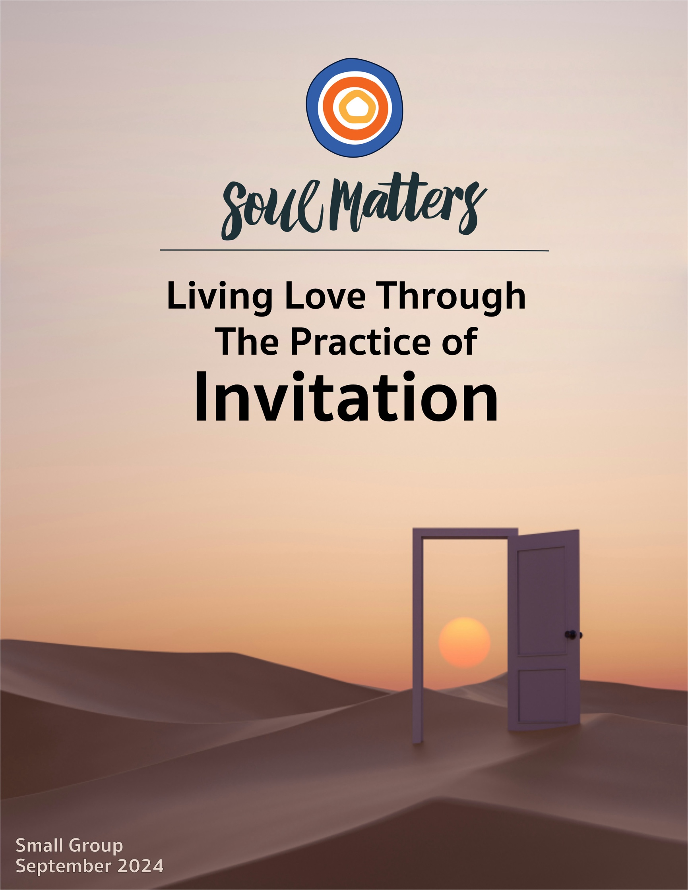

Welcome to the Practice of Invitation

Do not try to save the whole world
or do anything grandiose.
Instead, create a clearing
in the dense forest of your life
and wait there patiently,
until the song that is your life falls
into your own cupped hands
and you recognize and greet it.
Only then will you know
how to give yourself to this world
so worthy of rescue.
-Clearing by Martha Postlewaite

There is so much saving needed in this world of ours. Especially in this moment. Which is why this call for clearings and cupped hands seems so odd and out of place. Doesn’t this dear poet understand the urgency of the moment? Doesn’t she understand that we need to be lifting up our voices as loudly as we can, not carving out space for quiet? Doesn’t she understand that we need engaged hands not cupped hands, with all of us pushing as hard as we can against the tide and madly mending a world that is about to be torn in two?

Well, yes, she certainly could be clueless. But it’s also clear that she thinks we are the wrong-headed ones. Hers is an invitation to see that our urgent, muscular mode of saving is just not what the world needs.

And of course she is correct. In our better and clearer moments, we know the world needs us to be grounded and centered before rushing into battle. We need those cupped hands to catch our breath before we cover them with boxing gloves and engage the fight.

We also know that creating clearings is never a waste of time. The dense forest homes we so carefully cultivate keep us safe and comfortable, but they also make it hard to see the horizon and the newly rising sun. Clearings let that new light in and in turn help us notice when we are applying old ways of being and thinking to a world that isn’t here anymore.

Ah, that seems right. A good place to leave it. With us thanking the poet for her invitation to better understand what the world needs.

But there’s that pesky piece about the world handing our song back to us. That complicates things. It means this isn’t just an invitation to see what the world needs, but also an invitation to notice that the world sees us in need and is trying to give us a gift; an invitation to notice that the world is also an actor in this precious play, not just an object we are acting upon; an invitation to notice that while we are focused on saving the world, the world is also focused on saving us.

Or to put it another way, maybe the world is trying to love us. And we are being invited to let it.
Maybe that is what this talk of cupped hands is all about.

And if so, what a way to begin this new church year! And maybe even what a way to travel through our lives all the time! With cupped hands, remembering and open to receiving the love of the world.

Our Spiritual Exercises
It’s one thing to analyze a theme; it’s quite another to experience it. By pulling us out of the space of thinking and into the space of doing, these exercises invite us to figure out not just what we have to say about life, but also what life has to say to us!

Pick the exercise that speaks to you the most. Come to your group ready to share why you picked the exercise you did and what gift it gave you.

Option A

The Invitation that Isn’t Easy For Us

You likely saw this one coming. When the monthly theme is invitation, inviting someone to come to church seems an obvious exercise. What may not be obvious is the additional invitation to share with your invitee how church makes a difference in your life. This is where all of us understandably struggle. Sharing why church matters to us can feel uncomfortably close to the pushy proselytizing we want nothing to do with. But sharing how your church has given you a gift is quite different than trying to convince someone that your religion is the only right way. It’s one thing to tell a friend: “I’m worried about your soul and really want you to give your life to Jesus.” It’s quite another to tell them: “Hey, you mentioned that you’re feeling a hunger for community lately and I found that at my church, so I was wondering if you want to come with me to check it out.” One is about inviting; the other is about convincing.

Navigating your way through these complex and uncomfortable waters is what this exercise is all about. It’s not just about inviting someone to church; it’s about digging deeper into why that’s not just something you naturally and always do. It’s not just about fighting through the discomfort of telling someone why you love your church and why they may love it too; it’s about figuring out why that discomfort is there in the first place. And it’s not just about figuring all this out; it’s about finally feeling joy as you make this invitation to your friend.

Option B

The Invitation of a Story

Sometimes the best invitations are those made by a story. Here’s one about a hunter and the mythical “fox woman.”

As you listen to it, use our disciplined listening practice: i.e., ask yourself as you listen, “How is this story trying to offer me a message of comfort, a message of challenge, or reconnection with an important memory?”

A more focused question to listen with might be: “What have I lost through my decisions to disinvite the difficult?” or “Where am I being invited to embrace and invite in the full experience of something - the parts that are easy and beautiful as well as the parts that ‘stink’?”

Here’s the story: The Hunter and the Fox Woman - https://www.youtube.com/watch?v=Kn2DB11yL5A

Option C

An Invitation to Proclaim (Your UU “Alter Call”)

Growing up Southern Baptist, there was an invitation that was part of every worship service, a central part in fact. The altar call, an invitation to proclaim one’s belief in Jesus as one’s savior. Unitarian Universalists have a similar practice. (By the way, I love finding similarities between UUs and Baptists!) Core to our faith is a proclamation of beliefs, not of a single specific belief as was my Baptist background, but a proclamation of the beliefs that one has found to be true, one’s own creed, or credo statement as we like to call it. This is, in fact, the primary thing that drew me to Unitarian Universalism in the first place, the fact that we are not only welcome to but are invited to find and name our own beliefs and that no one is telling us what they should be. - Rev. Michelle Collins

What a great invitation to begin the new church year with: an invitation to anchor ourselves in a clear articulation of our core beliefs! To make it easier, and possibly more enriching, we’ve gathered a bunch of credo-like statements made by others. Here’s how to use them as partners to create your own statement:
- Read through a few, or all, of them.
- As you do so, write down phrases that strongly resonate with you. Try keeping your list to 5-8.
- Use that list of what you wrote down to create your own credo statement.
- To put your personal imprint on the list, you can…
  - order the list of statements in a way that reflects your priorities or a personally meaningful flow,
  - leave the wording as you found it and add your own short reflection to each statement,
  - rewrite the statements in language that fits you and speaks to your life,
  - turn the statements into a poem.

Here’s the list of others’ efforts…
- Nine Life Lessons - Tim Minchin
- 42, what feels true - adrienne maree brown
- Excellent Advice for Living - Kevin Kelly
- Eight Secrets - Oliver Burkeman
- Jonah - Rev. Steve Garnaas-Holmes
- The Only Dream Worth Having - Arundhati Roy
- 17 Life-Learnings - Maria Popova
- Three Rules to Live By - Laurie Anderson

Option D

Aging’s Invitation to You

Aging takes! And takes and takes. Ask most middle-aged and senior folks about the passing of time and this will likely be the most uttered response.

But what if there’s another way to look at it? What if aging isn’t just trying to take something from us, but talk to us?! Or to put it into the language of this month’s theme: what if aging is trying to offer us an invitation?

This is how spiritual teachers of all types approach aging and this is how this exercise encourages you to approach it this month. To help with the exercise, we’ve gathered a bunch of quotes, essays and videos that give voice to a variety of invitations that people have received from their middle and later years. You can find them by clicking on THIS LINK. Here’s our suggestions for working with them:

- Read through the ones that are relevant to your stage of life.
- Identify the two or three pieces that most resonate with you.
- Based on the pieces you choose, craft two or three statements/sentences of your own that capture the invitations your stage of life is offering you. This is the hard part, so take your time. You will likely end up revising the statements over and over. This is how it should be. The deeper we listen to life/age, the more refined our statements will become.
- Then share your statements with someone close to you. Start by sharing the two or three pieces that gave rise to your statements. Explain why these spoke to you and ask your conversation partner if the pieces speak to them as well. Then share your statements, asking your conversation partner if they agree that these seem like the invitations that fit you.

(The reason this exercise focuses on middle and late stages of life is that those are the two stages that most often get a bad rap. But don’t worry. We’ve got a bunch of stuff planned for you earlier adult folks in upcoming packets!)

Option E

Ask Them About Invitation

One of the best ways to explore our monthly themes is to have conversations about them with people who are close to you. It’s also a great way to deepen our relationships! Below is a list of questions to help you on your way. Be sure to let your conversation partner know in advance that this won’t be a typical conversation. Telling them a bit about Soul Matters will help set the stage.

Come to your group ready to share what surprised you about the conversation(s) and what gift or insight it gave you. As always, keep a lookout for how your inner voice is trying to send you a word of comfort or challenge through these conversions with others.

Invitation Questions:
- What relationship invited you to grow up the most?
- What parts of you have friendships invited to come out into the open?
- What do you wish you had disinvited from your life earlier than you did?
- Have you ever heard a healing invitation arise from illness?
- Have you grown more from what you’ve invited into your life or what you’ve disinvited from your life?
- If you could only invite two new things into your life in the coming year, what would they be?
- What question do you need to invite into your life in order to enter the next phase of your becoming?
- What is the most beautiful invitation you ever received?

Option F

Which Invitation Companion Piece Speaks to You?

Sometimes we come across a quote, song, article or movie and it perfectly captures what’s going on for us right now or allows us to view our current circumstances in a new light.

With this in mind, spend some time this month going through the Companion Pieces section below to find the one piece that speaks most powerfully to you.

As you do so, we encourage you to use the same discernment practice as we do with the packet’s list of questions: Go through them with an eye for the one that “shimmers” the most.
Come to your group ready to share the piece you picked, why it called to you and the journey it took you on.

Your Question

This list of questions is an aid for deep reflection. How you answer them is often less important than the journey they take you on.

So, read through the list of questions 2-3 times until one question sticks out for you and captures your attention, or as some faith traditions say, until one of the questions “shimmers.”

Then reflect on that question using one or all of these questions:
- What is going on in my life right now that makes this question so pronounced for me?
- How might my inner voice be trying to speak to me through it?
- How might Life or my inner voice be trying to offer me a word of comfort or challenge through this question?


- What is the most beautiful invitation you ever received?
- What relationship invited you to grow up the most?
- What is regularly on your to do list that was invited there by someone else, not by you?
- We all inspire and influence people with our way of being in the world. What is your way of being in the world inviting people to do or become?
- What question do you need to invite into your life in order to enter the next phase of your becoming?
- How are you being invited to know fear? i.e., to travel with fear, rather than fight to eliminate it from your life?
- Jungian analyst, James Hollis, writes, “Something within us knows us better than we know ourselves…It speaks by silently withdrawing energy from things that are not for us. It doesn’t care about our comfort; it cares about our growth.” So, how is your inner wisdom withdrawing energy from your life? And how is that withdrawal of energy inviting you to growth?
- This year, we’re exploring practices that help us embody our new UU core value liberating love.
Who’s “act of invitation” has taught you the most about what it means to love?
- Have you grown more from what you’ve invited into your life or what you’ve disinvited from your life?
- How has your life partner invited beauty into your life?
- How has parenting invited you to be more courageous?
- What have you unwittingly invited into your life in the past year? What snuck in without an invitation?
- If you could only invite two new things into your life in the coming year, what would they be?
- How are you being invited to return home?
- What’s your question? Your question may not be listed above. As always, if the above questions don't include what life is asking from you, spend the month listening to your days to find it.

Companion Pieces

Recommended Resources for Personal Exploration & Reflection

The following resources are not required reading. Nor are they intended to be analyzed in your group.
Instead they are here to companion you on your personal journey this month, get you thinking
and open you up to new ways of embodying the practice of invitation in your life.

Definitions

Invitation
1. the act of inviting, such as an offer of hospitality
2. the act of enticing or attracting; allurement
3. a provocation
4. a formal request to be present

Synonyms: encouragement, provocation, temptation, enticement, attraction
Antonyms: denial, refusal, discouragement, repulsion

Wise Words

Come, come, whoever you are,
wanderer, worshiper, lover of leaving.
Ours is no caravan of despair.
Come, yet again come.
Hymn #188

A real conversation always contains an invitation. You are inviting another person to reveal [themselves] to you, to tell you who they are or what they want.
David Whyte

I pray for you, world
to come and find me,
to see me and recognize me
and beckon me out, to call me
even when I lose
the ability to call on
you…
David Whyte

Change is not a threat to your life, but an invitation to live.
Adrienne Rich

We seem to think that beginning is setting out from a lonely point along some line of direction into the unknown. This is not the case. Shelter and energy come alive when a beginning is embraced… We are never as alone in our beginnings as it might seem at the time. A beginning is ultimately an invitation to open toward the gifts and growth that are stored up for us. To refuse to begin can be an act of great self-neglect.
John O’Donohue

Something within us knows us better than we know ourselves. It knows what is right for us. It speaks by silently withdrawing energy from things that are not for us. It doesn’t care about our comfort; it cares about our growth.
James Hollis

Life’s a party. Invite yourself.
Gary Johnson

Carl Jung once said in a BBC interview that he began calling God all those "things which cross my willful path violently and recklessly… and change the course of my life for better or for worse." The divine is that power which disrupts everything. So, what if our practice were to court a holy disruption? To welcome in everything which challenges my perspective on how the world works, which upsets all the plans I have for myself, and turns them on their heads? What if when life started falling apart, I opened my heart to welcome in the grief and fear that arrived as well and considered them as holy guides… What if all the painful feelings of loss and disorientation were invited in for tea and tenderness? What if everything that turns our preconceived ideas inside out is precisely where we find God?
Christine Valters Paintner
Our lives would be immeasurably enriched if we could but bring the same hospitality in meeting the negative as we bring to the joyful and pleasurable… The negative threatens us so powerfully precisely because it is an invitation to an art of compassion.
John O'Donohue

Ah, Grief, I should not treat you
like a homeless dog
who comes to the back door
for a crust, for a meatless bone.
I should trust you. I should coax you
into the house and give you
your own corner…
Denise Levertov

We grew up (and still live) in a world that constantly screams at us to seek pleasure… I don’t remember anyone ever telling me that it is worth striving for wisdom or strength of character.
Tristan Tell, on society’s invitations

Sabbath observance invites us to stop… It asks us to notice that while we rest, the world continues without our help.
Wendell Berry

I respectfully decline the invitation to join your hallucination.
Scott Adams

Do not neglect to show hospitality to strangers, for by doing that some have entertained angels without knowing it.
Paul’s letter to the Hebrews

The Arabs used to say,
When a stranger appears at your door,
feed him for three days
before asking who he is,
where he’s come from,
where he’s headed.
That way, he’ll have strength
enough to answer.
Or, by then you’ll be such good friends
you don’t care…
Naomi Shihab Nye
True hospitality is when someone leaves your home feeling better about themselves, not better about you.
Shauna Niequist

If justice is what love looks like in public, then inclusion is what love looks like among groups.
Rev. Dr. Matthew Johnson

On the Invitations of Love!

Love is at the center… like a flame on a chalice, burning brightly, igniting the values that surround it. The botanical nature of it seems to say that these values are rooted in and grow out of that center of love… They fill the spaces that surround them, and in each case, there is an opening for them to expand beyond their walls.
Rev. Tracy Johnson, on the flower graphic for our new core values centered in liberating love

There is a love that sets us free. Not free as in having the power to do whatever we want, but free as in not weighed down or bound by the patterns of hatred and control that get passed from generation to generation… Free as in knowing without a doubt that we are worthy and that it is ours to invite others into that same wisdom for themselves. Free to imagine a world where children are never in harm's way…
Rev. Dr. Sofía Betancourt

Love takes off the masks that we fear we cannot live without and know we cannot live within.
James Baldwin

Love isn't something natural. Rather it requires discipline, concentration, patience, faith, and the overcoming of narcissism. It isn't a feeling; it is a practice.
Eric Fromm

One thing I have observed: When we are engaged in acts of love, we humans are at our best and most resilient. The love in romance that makes us want to be better people, the love of children that makes us change our whole lives to meet their needs, the love of family that makes us drop everything to take care of them, the love of community that makes us work tirelessly with broken hearts.
adrienne maree brown

Videos & Podcasts

Bill Murray on Life’s Invitation to a New Day
https://www.facebook.com/reel/990746565599609

Inviting Fear to Travel with You
Elizabeth Gilbert
https://www.youtube.com/watch?v=pgKhHeiah80
https://www.youtube.com/watch?v=A-Pe0V9M1tw

An invitation from the birds…
Poem by Andrea Gibson
https://www.instagram.com/p/C4GlSpuO2fL/

The invitation of a 3-year-old girl…
Story by Andrea Gibson
https://www.instagram.com/p/Ctpo78GvZg2/

On inviting in our feelings and hearing their invitations
https://www.youtube.com/watch?v=6oFD8gbic6A&t=409s

The Story of The Hunter and the Fox Woman
https://www.youtube.com/watch?v=Kn2DB11yL5A
On the dangers of what we disinvite from our lives.

Grief as an invitation
Dr. Bayo Akomolafe
https://www.youtube.com/watch?v=rcu60pvVs8s

Complicating the Invitation to “Save the Planet”
Dr. Bayo Akomolafe
https://www.youtube.com/watch?v=PANfg8xC1sk

On the Life-Giving Questions that Change Invites Us to Ask
https://www.youtube.com/watch?v=Tt0arZN6EBM

Music
Each of our theme-based playlists - on Spotify and YouTube - is organized as a journey of sorts, so consider listening from beginning to end and using them as a personal musical meditation.

Click here for the Spotify playlist on The Invitation of a New Day
Click here for the YouTube playlist on The Invitation of a New Day

Click here for the Spotify playlist on The Invitation to Live Love
Click here for the YouTube playlist on The Invitation to Live Love

Books

Hospicing Modernity: Facing Humanity's Wrongs and the Implications for Social Activism
On inviting the end of modernity’s denials and damage

Trusting Change: Finding Our Way Through Personal and Global Transformation
On inviting change into our lives

Faithful Practice: Everyday Ways to Feed Your Spirit
On inviting spiritual practice into our lives

Movies & TV

The Bear
On the invitation to community and beginning again

Somebody, Somewhere
On the invitation to self-reinvention

Once
On the invitation to connect and heal

Rectify
On second chances and the invitation to a new day

The Great Disconnect
On the invitation to reconnect

Inside Out 2

On inviting in all of our emotions

© 2024-25 Soul Matters ALL RIGHTS RESERVED
Packets are for use only by member congregations of the Soul Matters Sharing Circle.
Learn how to join at https://www.soulmatterssharingcircle.com

